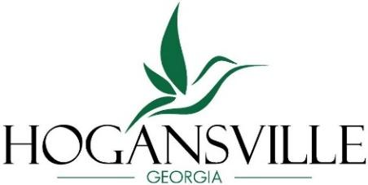 City of Hogansville
Historic Preservation Commission
Regular Meeting Agenda
Tuesday, June 16, 2026 at 6:30 pm
111 High Street, Hogansville GA 30230T
Chair: Wanda Lowe 2028
Board Member: Carol Smith 2026 Board Member: Nicholas Murphy 2026 Board Member: Mary Ann Neureiter 2028 Board Member: Wendy Stolarick 2027
Board Member: Kristian Whisnand 2028 Board Member: Eli Kouns 2028

\
Approval of Agenda

Approval of Minutes – February 17, 2026

New Business
- Certificate of Appropriateness Application for 201 Johnson Street, Parcel No.
0244W001003
- Certificate of Appropriateness Application for 811 East Main Street, Parcel No.
0213B006006

Member Concerns

Announcements

Next Meeting – September 15, 2026

Adjourn

